|  |  |
| --- | --- |
| **Information** | **Detail** |
| **Full name** | Nguyễn Hải Sơn |
| **Date of birth** | 20.12.1992 |
| **Sex** | Male |
| **Marital status** | Married |
| **Telephone** | 0976222692 |
| **Address** | Phú Cường- Sóc Sơn- Hà Nội |
| **Mail** | haison201212@gmail.com |

**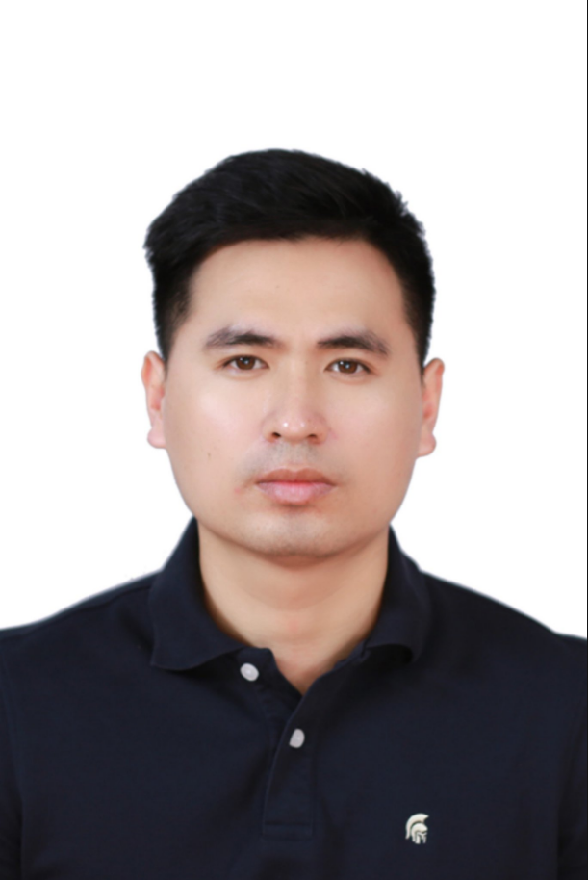  
Degree**:

I graduated **university of economy and technology for industry** and my major was **electrical and electronic engineering technology**.

**Skill** :

* Can work under pressure.
* Fluent at English.
* Can work in group or individual.
* Can use office software well.
* Know how to use 7 QC tools , 5W2H, 4M1E , PDCA, PFMEA,…
* Know how to make 8D , other reports effectively .
* Have Ability to learn and solve issues quickly and effectively.
* Have experiences working directly with foreign customers : reporting , representation , guide line qualification.
* Have management skill to manage and distribute work to team members.
* Have high sense of responsibility and always proactive solve any problems .
* I’m sociable so I’m willing to join collective activities of company.

**Work experiences**:

* June 2021 – now : **Working in QA Dept** of SEI electronic company in Quang Minh industrial zone : a CM of apple company – type of product : electronic components related to FPCA
* 2018-May 2021 : **Worked in PM Dept** of BLD companyin Quang Minh industrial zone : a vendor of SamSung company – type of product : Lens of camera
* 2015- May 2018 : **Worked in QA Dept** of Elentec companyin Quang Minh industrial zone : a vendor of Samsung company- type of product : Electrical , plastic parts for Samsung smart phone : batt , cover, rear, front,..

Currently, I’m working in QA team of SEEV company and working as **a senior engineer.**

My main tasks include :

* + Manage quality status and ensure the yield meet target.
  + Work directly with customer and follow their requests.
  + Calculate and distribute works to my team members.
  + Make internal and external reports for daily, weekly, monthly yield and quality , CR reports…
  + Co-operate with all relevant Depts to build products in NPI phase , make reports and documents : readiness list , PFMEA , NPI yield , FACA reports,.. before line qualification and mass production .
  + Make NG daily and weekly reports to find out reasons for countermeasures .
  + In production process , there are any quality issues , I'm responsible to handle them and leading team to handle them.
  + Work with relevant team to find out the solutions to enhance yield.
  + Prepare documents for internal, external audit and customer’ visits.
  + When customer ask to make 8D report with serious quality issues . I’ll lead team to due with it and report to customer .
  + Receive other tasks from my manager and handle them

Secondly, I worked in PM department of BLD company and I worked as **a supervisor** .

My main tasks included :

* Manage materials and OPs of my team.
* Receive production plans from sales department and make specific plans to my department.
* Arrange OP and materials logically.
* Distribute works to subordinate and receive works from superior.
* In production processes, there are any problem I have the responsibility to handle them to guarantee flow of production.
* Receive feedback of customers related to the production and handle them as soon as possible.
* Interact to customers directly about production status, production reports for daily, weekly , monthly...
* Check and make reports of inventory of products including finish products and unfinished products ,...
* Look for solutions to enhance effectiveness and reduce OP.
* assess OP , leader periodically once a year.

Firstly, I worked in QA department of Elentec company and my team was CS ( customer service ) and patrol audit team. My position was a **supervisor.**

My main tasks included :

* Manage members and equipment of my team
* Check and control 3D5S of all departments and require changing logically.
* Lead all relevant departments to Investigate and give solutions when products get NG.
* Receive and respond all feedbacks of customer about quality.
* Handle issues occurring in customer side as soon as possible to avoid affecting the production process.
* Join the new model process to build production process (SIP), Quality control plan ( QCP), PFMEA , … and submit required documents to customer for assessing and approving
* Prepare documents to customer’s inspections.
* Appraise proficiency and certificate to all QC workers.

**Career Goals** :

* Always want to cultivate work experiences and complete my self .
* Always try to complete any tasks effectively and quickly .
* Try to achieve zero customer’s claim .
* Can be a QA manager in future when getting enough ability and knowledge .