|  |  |  |  |  |  |
| --- | --- | --- | --- | --- | --- |
| **I – GENERAL INFORMATION** | | | | | |
| **Full name** | NGUYEN TRONG TUAN | | **Gender** | | Male |
| **Place of birth** | Tam Dao district, Vinh Phuc Province | **Date of birth:** | Feb. 08th 1987 | **Marital Status** | Married |
| **Identity Card No.** | 135420692 | **Issued on** | 10/01/2006 | **Issued at** | Vinh Phuc |
| **Email** | *trongtuan8287@gmail.com* | | **Phone No.** | 0868.647.820 | |

**CURRICULUM VITAE**

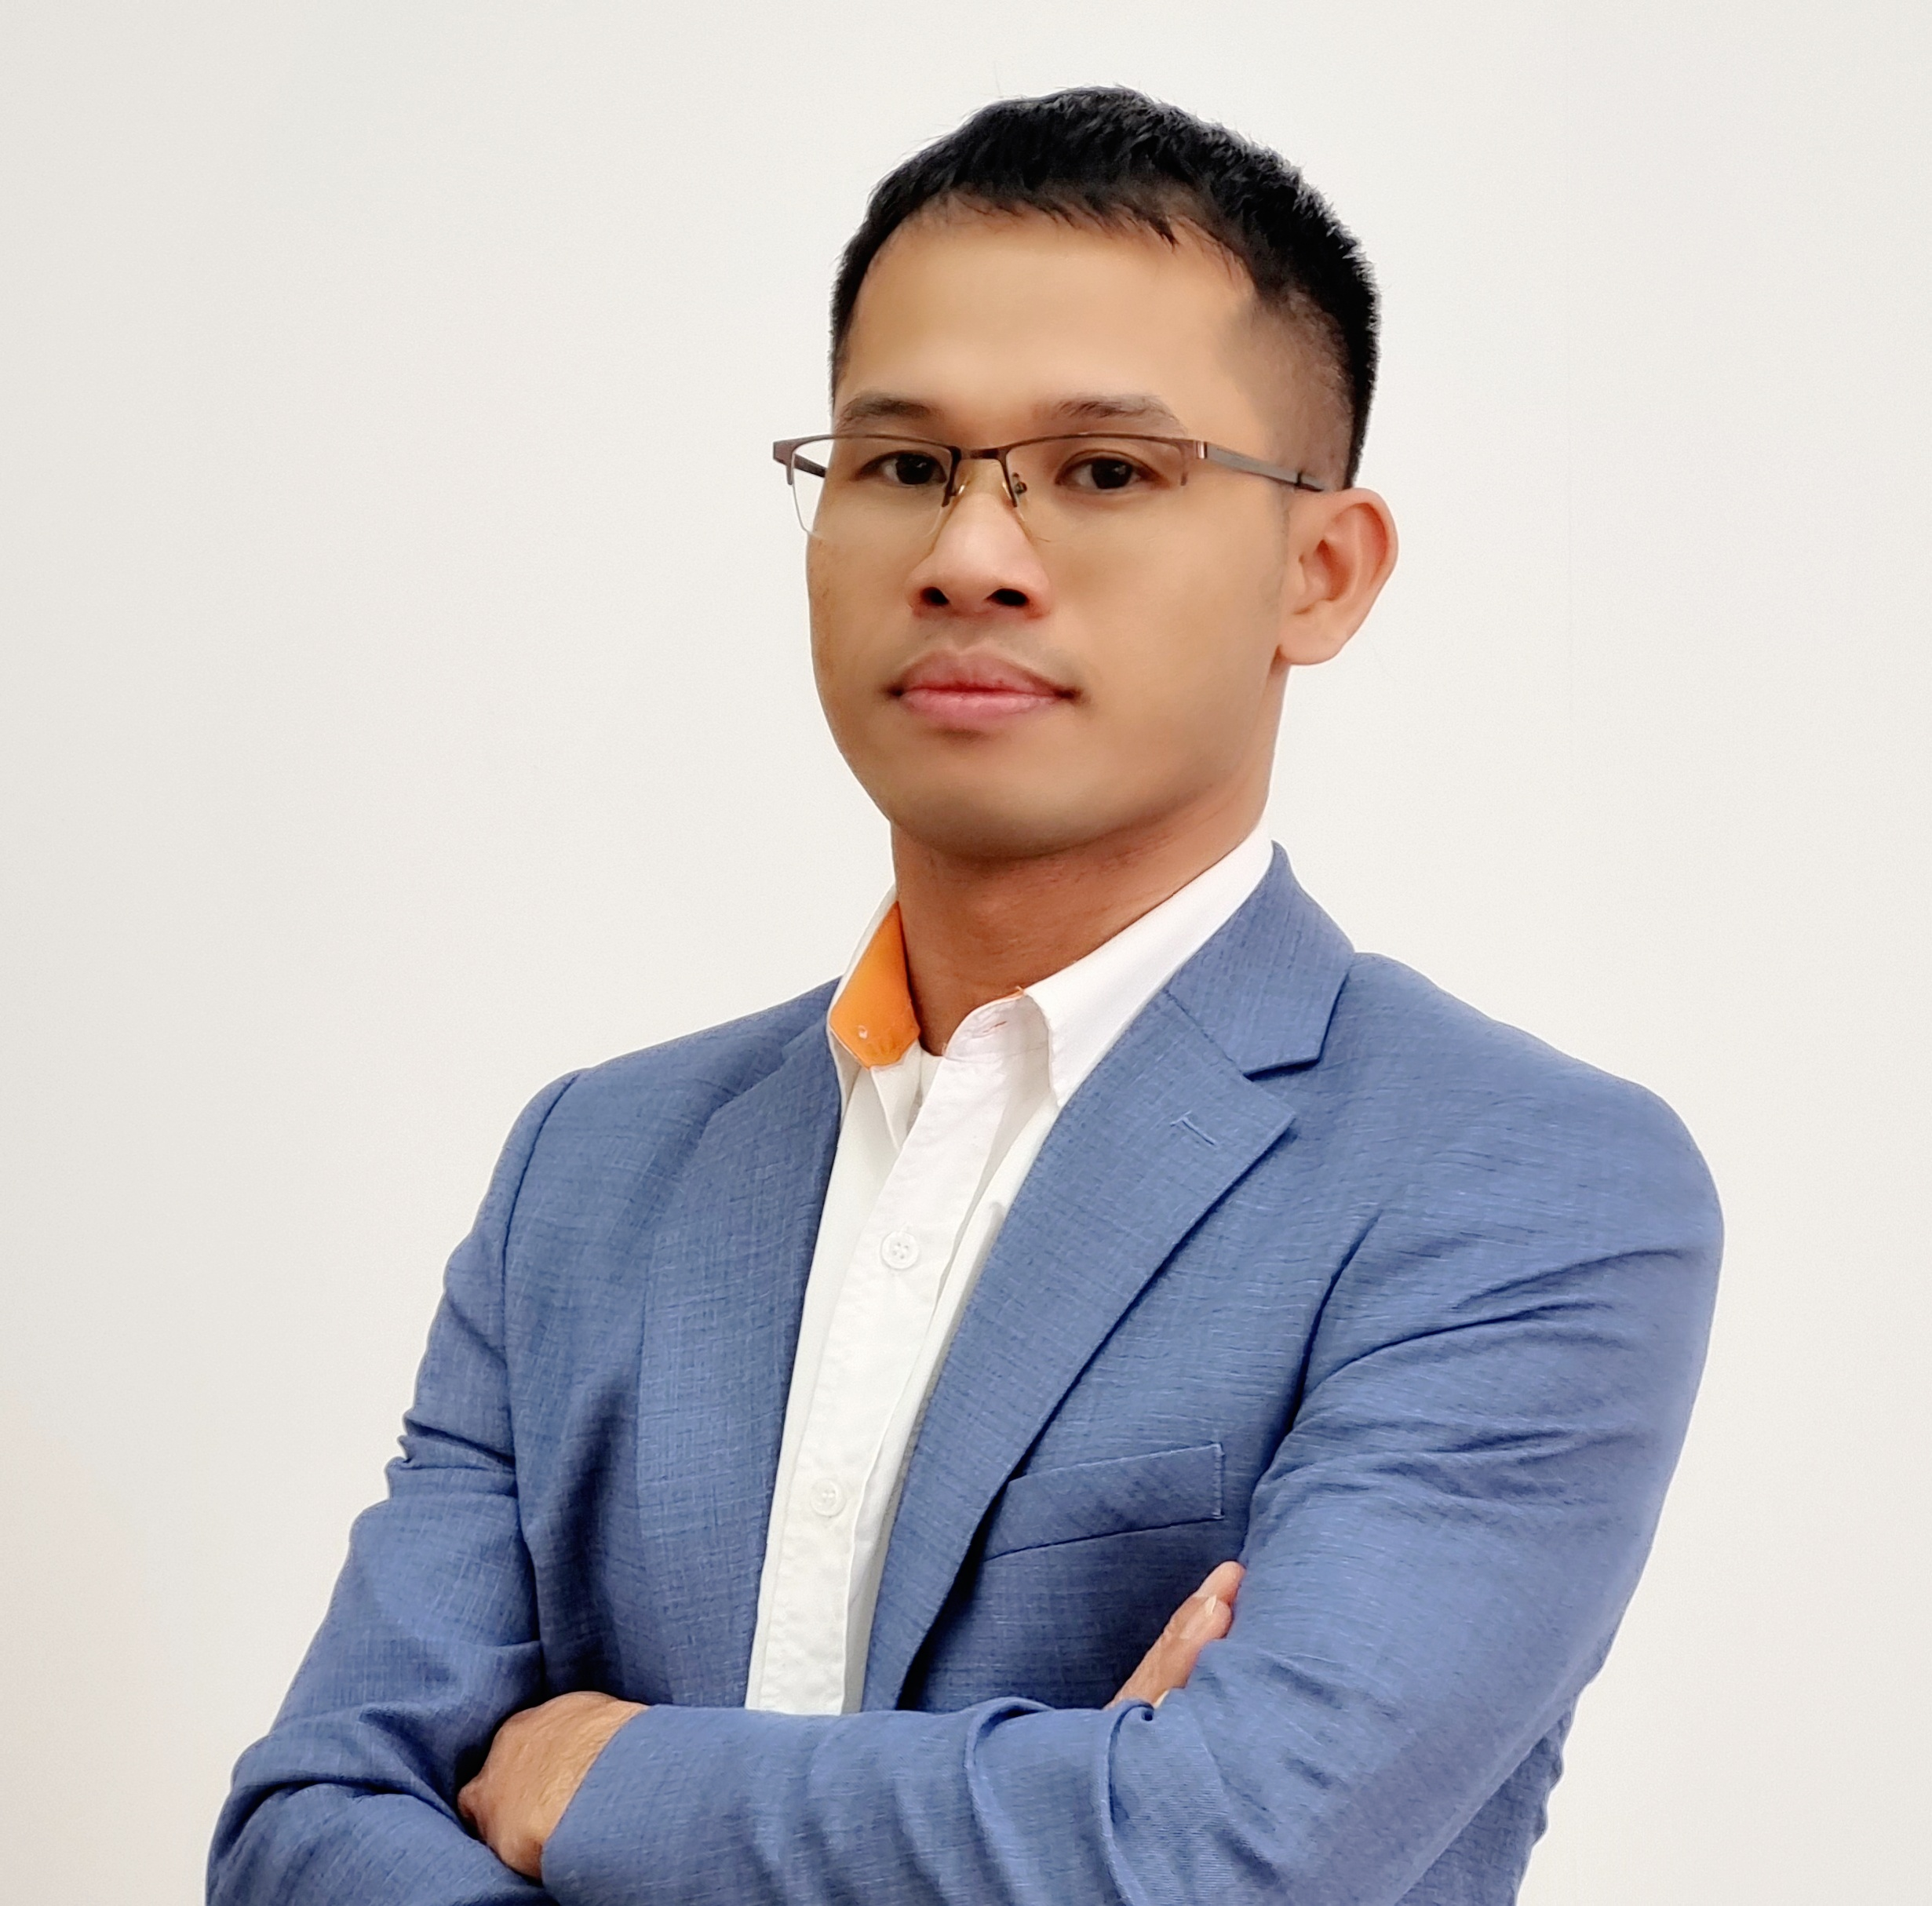

**II - RESUME**

|  |
| --- |
| **1. DESIRED POSITION** |
| Production Director |
| **2. OBJECTIVES** |
| • Taking charge of important position in company in coming 2 years.  • Getting more knowledge and experience in order to improve myself.  • Build up professional working environment. |
| **3. EXPERIENCES** |
| • ***2010***: The Leader of the English club at University.  • ***3/2010:*** Taking part in an “English contest eloquent among Thai Nguyen Universities”.  • ***2011-7/2015***: Working at **CANON** company as PE Team Leader.  • 7/***2015- 2/2019***: Working for **SINDOH** company as PE Manager.  *(****3/2016- 4/2017****: Training at Sindoh R&D center in KOREA).*  • **2/2019- 7/2021**: Working at Representative Office of **LSMtron Group** in Viet Nam as  **Sales Executive** to sale Injection molding machine in all Viet Nam market.  • 7/***2021-Now***: Working at CNCTech Solutions as **Production Director**.   1. **CANON COMPANY:** 2. ***Product Engineering Team Leader: Control 12 Engineers***   ▫ Assign the daily job to all members before start working day.  ▫ Receive technical information from Japan side. Assign member to implement,  follow and inform to related department.  ▫ Instructing to member for difficult problems to solve quickly and timely.  ▫ Giving the judgment base on the technical knowledge. Decide repair method,  testing items (using jig, operator,...) when part NG.   1. ***RESPONSIBILITY FOR LAUNCHING NEW PRODUCTS:***   ▫ Being a leader to develop successfully 8 new products (2013-2014: 4 models;  2015-2016: 4 models).  ▫ Evaluate and feedback technology, all current problems of products to R& D  Japan to avoid them to happen in new models.  ▫ Receive drawing, technical issue of new model. Confirm and check again the  margin of design to make sure that’s suitable with mass production.  ▫ Getting 3D machine, DE machine (design evaluation machine). Decide the  responsibility for each member to check and investigate. Find out the not good  points, risk points then request to change design concept and drawing.  ▫ Creating activities, strategy to build a best product of new models:  ***Example:***  ▫ **Jig activity**: Cooperate with Automation Engineering department to study new jig  to apply for new model. Improve the NOT good points from jig to ensure function  of product. Create new jig as we can to support operator job. We make jig list and  details schedule, action item for each period before Mass Trial.  **▫ Trend management:** Testing and getting data about some important points: sound,  printing accuracy, gap of cover, part’s ability, force to check margin of design. If  the data show not good, we request change design or specification.  ***▫ One Pass Rate:***  Give optimal solution to reduce the assembly time/ Cost down, raise product’s quality by change operation, layout.  ▫ ***Re-Occur Prevention****:* That solves parts/ Printer problems which have been happening or find hidden troubles to make it don’t reappear again.   1. **SINDOH COMPANY:** 2. **3/2016- 4/2017: Training at Sindoh R&D Center in KOREA:**   ▫ Getting training knowledge about printer design process, method and testing items.  ▫ Learning Korea culture and working style.  ▫ 2/2017: Getting 2 months training course at **China Factory**.   1. **4/2017- 2/2019: Product Engineering Manager.**   ▫ Making a policy, target for our department every month, year.  ▫ Give the solution when problem happen at Line or QA to ensure part’s quality.  ▫ Receive feedback/ claim from customers then investigate cause and give solution.  ▫ Receive ECN, technical documents from R&D and implement at Sindoh Vina.  ▫ Responsibility for developing MOLD die fields: Understand well about MO resin,  MO machine condition, solve MO problems  ▫ Support Vendors to improve MO parts quality, solve part issue  ▫ Knowledge about 5S/ quality control (7 QC tooling) & ISO (9001/ 14001):  + Joining ISO training course regularly.  + Understand well about IATF, ISO Standard (ISO 9001/ ISO 14001).  + All judgment/ daily job must follow two ISO above to raise up and ensure quality,  protect and keep environment fresh.   1. **LSMTRON COMPANY:**   ▫ **2/2019- 7/2021**: Working at Representative Office of **LSMtron Group** in Viet Nam as  **Sales Executive.** LSMtron was established in 1969 in Korea as part of **LG Group**  until 2008. After that, changed name to LSMtron to focus on producing Tractor,  Injection machine, Electric components, etc to export to over 50 countries in the  world.  ▫ Control all Agents in Viet Nam (total: 5 agents)  ▫ Finding out potential customers, take care all current customers by phone call, sending  email and meeting to get the feedback & know the new plan of each customers,  getting the sales order. Handing to take care list 485 customers in Viet Nam and 50  current customers. Promote & marketing company by advertising on internet, issue  magazine, take part in exhibition.  ▫ Translating documents from Korea or English to Vietnamese (marketing documents,  Vietnam website, Vietnamese Sale Contract, Vietnamese Catalog, etc).   1. **CNCTECH SOLUTIONS:**   ▫ **7/2021- Now: Production Director at CNCTech Solutions.**  ▫ Manage ***Production/ QC/ R&D/Mold/ Plan/ Maintenance/Warehouse*** departments  to ensure quality, productivity and delivery schedule to customers.  ▫ Analyze 2D/3D drawing for new models, new project. Cooperation with sales team to  make a quotation. Making master plan to develop new models& follow up.  ▫ Control all machines & equibments in the factory. Make maintenance schedule.  ▫ Control production plan base on customer’s PO, build up commend and reward the  innovations for employees. Make a shorts/long term plan to develop team. ▫ Searching a news customers and build up a good relationship with current clients. ▫ Doing cost down, quality activities, trainning program to optimization production.  ▫ Ensure sales revenue always increase every year ( 20 bililion/month).  ▫ Control production cost, electric and manpower cost for the best optimal.  ▫ Always making a good environment for employees, keep company rule and ensure 5S. |
| **4. EDUCATION** |
| • **2014~2015:** Joining the special Japanese class at Canon company (2 people/ class).  • **Dec/2014**: Came to **Japan** for business trip in Nov/2014.  **• 2011** graduated from Thai Nguyen University of Technology.  • **2008 - 2010**: Studying some software at CAD/CAM/ CNC centre in Thai Nguyen.  I have been using AutoCAD and CATIA V5, Inventor software to design.  • **2012**: Taking part in Molding training course in CANON.  • Joining “ABC_ Aware before change” soft skills course.  • TOIEC (English): **850 points**.  • TOPIK (Korea): **Topik 4**  • JAPANESE: **N5 ( basic)** |
| **5. SPECIAL SKILLS** |
| • Good communication and interpersonal skills.  • Good at **English** and **KOREA** communications (4 skills).  • Capable of working under pressure  • Good computer skills (Word, Excel, Power point, Internet).  • Able to work independently as well as in team. |

***I hereby affirm that all information given above is true!***